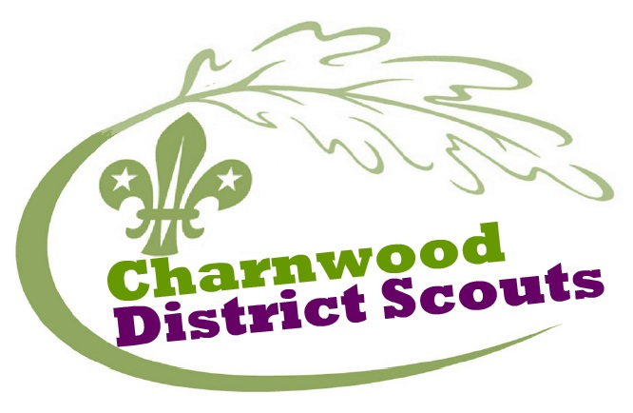

ROMAN CAMP

Join us for a fantastic weekend of Roman Adventure!

Take part in lots of exciting activities including inflatables, zorbing, axe throwing, archery, mountain biking and a life size game of Hungry Hippos!

This is a Roman themed camp which also incorporates St Georges Day celebrations.

So pack your toga and come to camp!

Venue: Rough Close Scout Camp site, Tanners' Ln, Berkswell, Coventry, West Midlands CV7 7DB
Dates: 22 - 24th April 2016
Scout/ Explorer cost £ 50.00- £10.00 non refundable deposit required by 19th Feb. Balance required by 24th March

We hope to see you at camp!
Name:…………………………………………….

Group:…………………………………………….

T-Shirt Order:

Size | Small | Medium | Large | Extra Large
Chest Size (Inches ) | 38 | 40 | 42-44 | 46
Please tick the size your child needs.

I enclose a £10.00 non- refundable deposit. (If it is a cheque please make cheques payable to …………………………………………………………………………….. )

Signed: ……………………………………………………………………. (Parent/Guardian)

