Pirate games

WALK THE PLANK / PIRATE DUEL
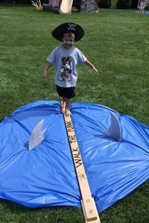
For younger children a simple task to walk across the plank without losing balance is a fun challenge.
For this pirate game you will need a plank which you can make yourself with a long board. You don’t need to have it far off the ground (you don’t want any injuries) but you can prop it off the ground a little with milk crates, old tires, etc. Just make sure it is sturdy enough for the kids to stand on without wobbling. If you're feeling really festive you can create an sea-worthy atmosphere around it like in the picture.

For the older kids who need a bit more of a challenge you can include the element of a pirate duel. Any self-respecting pirate will know how to wield a sword, especially in desperate situations. Two pirate participants, armed with swords, step onto the plank and duel while maintaining their balance. The person to stay on the longest is the winner, and the next two pirates take their turns.
You can make your own swords from those long balloons used for balloon animals, pool noodles, or purchase fun inflatable theme swords

CANNONBALL BLAST!
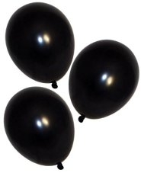
A black balloon is tied to a string and the other end of the string is clipped or tied around the pirates leg. When the whistle blow it’s every man for themselves as players try to pop the other players cannons while at the same time trying not to get their balloon popped. They must do this without using their hands. The player whose cannon ball last the longest wins!

Hook the treasure
Using your already made pirate hook, empty a large bag of pretzels into a bowl. Let’s see how many pretzels the kids can fish out with their “hooks” in 60 seconds.

PEG LEG RELAY
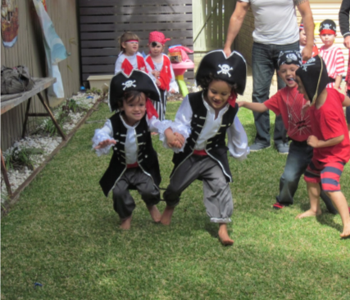
Need more kids pirate party ideas and games? How about a pirate relay race? Pirates are divided into pairs of two. One of each of their ankles are tied together to form the peg leg. The game is played just like a three legged race. Players must learn to cooperate with each other to make it to the end. The first team to cross the finish line wins!

Bobbing for Apples
Hang cored apples at the kids height. Then the kids have to bite the apple with their hands behind their backs. It’s a simple and classic game, but the kids love this sort of pirate games

Pin the Parrot/Patch on the Pirate (or Pin the Pirate on the Map)

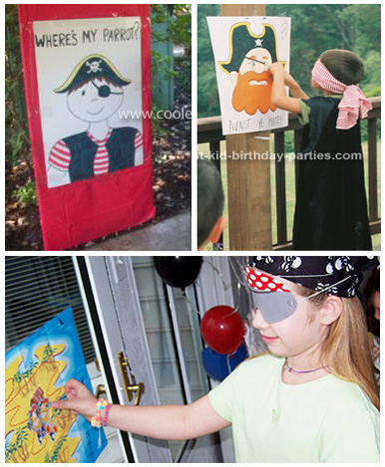
Fun game with the same rules as “Pin the Tail on the Donkey”. Draw a pirate on posterboard and make parrots out of construction paper. A bandana for a blindfold and have each child try to pin the parrot on the shoulder of the pirate. Fun game, the kids loved it!

Gummy Bear Contest
Fill a plate with whipped cream and hide a bunch of gummy bears in them. Players have to hold their hands behind their back and retrieve all of the gummy bears by using just their mouths.

