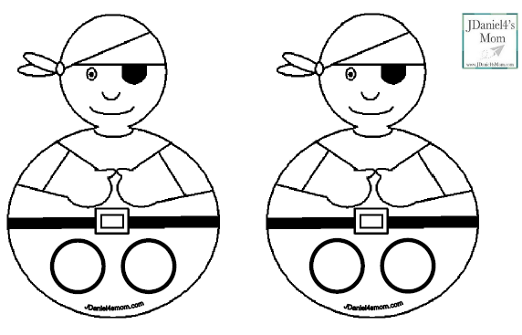

Pirate finger puppets

Supplies
- Five Little Pirates Craft and Patterns
- Scissors
- Material or Cut Up Bandanas
- Crayons, Markers, or Colored Pencils
- Glue Sticks

Steps for Putting the Puppets Together
First, you will need to decide if you want to cut the puppets out for your children or cut them out for them in advance.
Next, you can have your children color in their puppet with whatever drawing materials you like. I thought you might use crayons, markers or colored pencils. You may have other drawing materials would like for them to use.
Then you could have them cut and paste material onto their puppets to give them texture if you like. They could give their pirate a felt eye patch or mini bandana made of part of a real bandana.
Once your children have their puppets completed, you can work on the rhyme.
