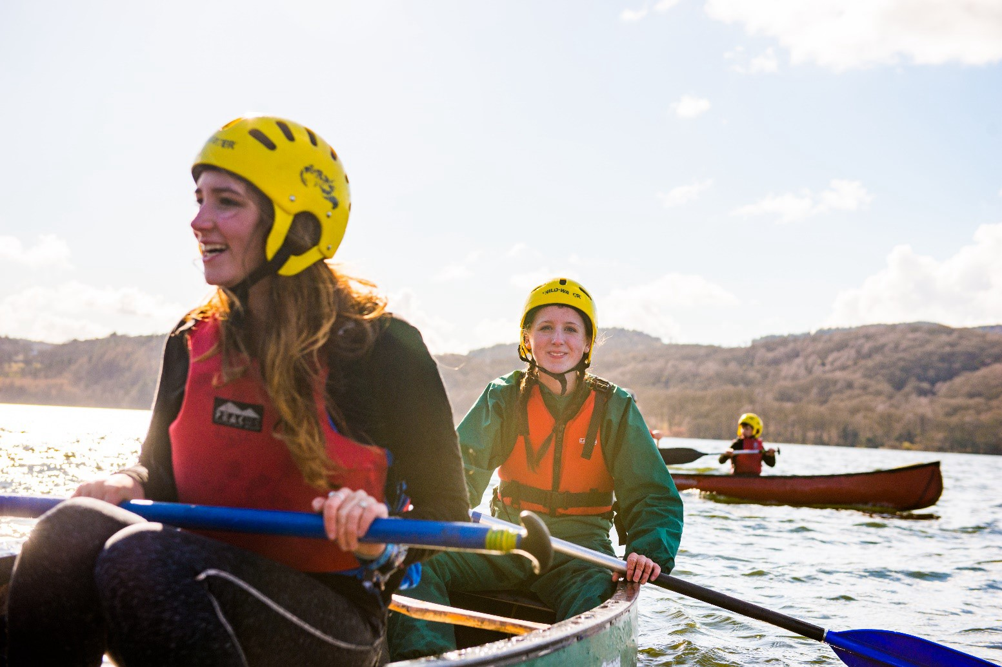

**Group Lead Volunteer**

**Information for anyone considering the role of Group Lead Volunteer for 40th Leicester (Anstey) Scout Group**

**scouts.org.uk/join #SkillsForLife**

*Please note that we have used the term ‘Scout County’ throughout this pack: in Wales and Northern Ireland these are known as Areas, and as Regions in Scotland.*

# About us

## Overview of Scouting

We are the UK’s biggest mixed youth organisation. We change lives by offering 4 to 25 year olds, fun and challenging activities, unique experiences, everyday adventure and the chance to help others so that we make a positive impact in communities.

Scouts helps children and young adults reach their full potential. Our members gain valuable skills for life including teamwork, time management, leadership, initiative, planning, communication, self-motivation, cultural awareness and commitment. We help young people to get jobs, save lives and even change the world.

**What do Scouts do?**

Scouts take part in a wide range of activities as diverse as kayaking, abseiling, expeditions overseas, photography, climbing and zorbing. As a Scout you can learn survival skills, first aid, computer programming or even how to fly a plane. There’s something for everyone. It’s a great way to have fun, make friends, get outdoors, express your creativity, and experience the wider world.

**What do volunteers do?**

This everyday adventure is only possible thanks to our team of adult volunteers, who support Scouts in a wide range of roles from working directly with young people, to helping manage a local community-based Group, to being a charity Trustee. We help volunteers get the most out of their experiences at Scouts by providing opportunities for adventure, training, fun and friendship.

Our award-winning training scheme for volunteers means that adults get as much from Scouts as young people. Our approach focuses on what you want to get out of volunteering with Scouts, while respecting how much time you can offer. Over 90% of Scout volunteers say that their skills and experiences have been useful in their work or personal life.

## Key facts and figures

The Scout Association is a UK charity founded in 1907 and now boasts a membership of over 620,000 young people and adult leaders. We are the largest mixed youth movement in the UK. Scouting activity is delivered through 7,000-plus community-based Scout Groups nationwide.

Scouting is widely recognised and is one of the most trusted charities in the UK, giving it a significant level of influence and responsibility. Scouting’s greatest strength lies in its grass roots. It is locally that Scouting is best able to identify and work directly with young people most in need.

We believe that through the everyday adventure of Scouting, young people and adult volunteers regularly experience new challenges that enrich and change their lives.

The current focus for the Trustees and those in Scouting in the UK is delivering our strategic vision.

# A group of people in a room AI-generated content may be incorrect.Our strategy

A new strategic plan for Scouting across the UK is currently nearing completion to secure a strategic direction through to 2025 and to grow on the success of the current plan. Team UK (the team of commissioners that leads Scouting across the UK) will play a key part in leading the delivery of this strategy. More details on the work towards our new plan are available [online.](http://www.scouts.org.uk/ourplan)

**By 2025 we will have prepared more young people with skills for life, supported by amazing leaders delivering an inspiring programme. We will be growing, more inclusive, shaped by young people and making a bigger impact in our communities.**

# Scouting’s fundamentals

## Our mission

Scouting exists to actively engage and support young people in their personal development, empowering them to make a positive contribution to society.

**Our values**

As Scouts, we are guided by these values:

**Integrity**

**Respect**

**Care**

**Belief**

**Co-operation**

[Further information on our fundamentals, including details of](https://www.scouts.org.uk/por/1-our-fundamentals/) [our values, are provided on our website.](https://www.scouts.org.uk/por/1-fundamentals-of-scouting/)

# Scouting’s key policies

In common with all members in Scouting, Group Lead Volunteers are required to promote and follow our key policies. The policies cover:

**Development Policy**

**Equal Opportunities**

**Privacy and Data Protection**

**Religion**

**Safety**

**Safeguarding**

**Vetting**

**Youth Member Anti-Bullying Policy**

[These policies are fully explained on the Scouts website](https://www.scouts.org.uk/about-us/policy/)

# 40th Leicester (Anstey) Scout Group

40th Leicester (Anstey) Scout Group is a successful and thriving Scout Group located within Charnwood District and is made up of 3 sections.

The group currently has:

* 24 Beaver Scouts (6 - 8 year olds) in 1 Beaver Colony
* 33 Cub Scouts (8 - 10 ½ year olds) in 1 Cub Pack
* 20 Scouts (10 ½ - 14 year olds) in 1 Scout Troop
* 20 Adults (18+ year olds)

The Group has a dedicated adult leader team providing excellent programs for our Young People to give them #SkillsForLife. The group also has a supportive Trustee Board providing governance oversight for the group. Fundraising and maintenance teams are in place to help keep the group running smoothly with background tasks and event planning. The are admin support volunteers in place to assist the GLV with some of the day-to-day admin of the group.

The group is very active and attend many District and County events.

The group is based at the recently refurbished Jubilee Hall on Stadon Road, Anstey. The hall is a community facility that the group share with other members of the community. There is a dedicated storage facility at the hall that the group uses to store section and camp equipment.

# The current vacancy

We’re currently looking for a Group Lead Volunteer. This is a management role, and we need someone who can provide leadership, motivation and guidance to our adult volunteers.

A large part of this role involves managing and supporting adult volunteers, including those working directly with young people. For any adult volunteer in scouting, their manager will be a regular port of call for support

You don’t need any prior experience of Scouting to apply for this role, we’ll make sure you’re fully trained and supported. The management structure of Scouting is as follows:

In addition to adult volunteers, Group Lead Volunteers also ensure that support is available at every level, so that all volunteers feel valued, motivated, inspired and focused on providing first-class Scouting for young people. The most successful Group Lead Volunteers recognise the importance of valuing the hard work of volunteers, seeks to ensure that they feel happy and supported week after week, and that they are thanked for what they do.

The Group Lead Volunteer provides direction for the Group and will help others see the bigger Scouting picture through their leadership.

We encourage everyone in management roles within Scouting to adopt an approach that combines the skills of both leadership and management.

# Core Skill Areas

We’ve identified six core skill areas that make a good Scouting manager and leader:

## 1. Providing direction

Core

Skills

Managing

time and

personal

skills

Providing

direction

Working

with people

Achieving

results

Enabling

change

Using

resources

A good Group Lead Volunteer will create a vision for Scouting in their Group and provide clear leadership to implement that vision.

**2. Working with people**

It is vital that a Group Lead Volunteer can create team spirit amongst the other volunteers they work with, and can form effective working relationships based on trust and the fundamental principles of Scouting:

* integrity
* respect
* care
* belief
* cooperation

## 3. Achieving results

Group Lead Volunteers ensure that goals are achieved, plans are seen through to completion, and that good relationships are maintained both with the parents / carers or guardians of the young people within the scout group and within the local community.

## 4. Enabling change

It is important for a Group Lead Volunteer to encourage volunteers to think of creative ways to improve Scouting across the Group. They should then provide the support to implement appropriate changes.

## 5. Using resources

A Group Lead Volunteer will ensure that information and resources are available, helping volunteers across the Group to continue to provide excellent Scouting opportunities to young people.

## 6. Managing time and personal skills

A good Group Lead Volunteer should use their time effectively and be willing to continue to learn and improve their skills.

Follow this link for more information on [core skills](https://www.scouts.org.uk/volunteers/running-things-locally/recruiting-and-managing-volunteers/leadership/leadership-and-management-a-video-series/) (we are working on getting these videos up to date)

**We’re looking for someone that can grow into the role**

We are looking for an individual or team of people with the above skills to ensure that Scouting in 40th Leicester (Anstey) thrives. So, if you have some of the skills detailed and the drive and enthusiasm to develop Scouting in 40th Leicester (Anstey), you could be the person we are looking for. You can expect to receive support and training as part of your development within this role.

# How to apply

## Process

Thank you for your interest in volunteering. On the following pages you will find a role description and the person specification. The Group Lead Volunteer’s nomination and application forms are on pages 10 and 12.

You can apply for the role yourself using the application form or nominate someone else using the nomination form. Nominated people are under no commitment to apply unless they wish to.

Shortlisting will be based solely on the information provided by each candidate in their application form. All applications should address the requirements of the role, as laid out in the role description and person specification.

## Key dates

The closing date for applications is **Friday 4th July 2025.**

Interviews will be held week commencing Monday 7th July 2025.

## Further information

For more information, or for an informal chat about this vacancy, please contact:

Name: Nick Fordyce

Phone: 07976697084

Email: [nick.fordyce@charnwoodscouts.org.uk](mailto:nick.fordyce@charnwoodscouts.org.uk)



# The role - Group Lead Volunteer

**Role description**

**Outline:**

To manage and support the Scout Group to ensure it runs effectively, and that Scouting within the Group develops in accordance with the rules and policies of The Scout Association. To ensure the Group provides good quality Scouting for young people and proactively supports and manages adults in the Group.

**Responsible to:** District Lead Volunteer, District Team

**Responsible for:** All adults and young people in the Scout Group.

**Main Contacts:**

* Parents, Carers or Guardians of the young people in the Scout Group,
* Trustee Chair, Trustee Treasurer, Trustee Board Members
* Section Lead Volunteers,
* District Lead Volunteer, District Team Members
* County Lead Volunteer, County Team Members
* wider community contacts, other youth organisation leads, etc

**Appointment requirements:**

Must complete the relevant training for the role within the prescribed timescales. Must be eligible for charity trustee status (as a member of the Group Trustee Board). This role will include contact with young people and will therefore require disclosure checks.

**Main Tasks**

* Ensure that the Group thrives and has the best systems in place to support adult volunteers and to develop the Group, including the Trustee Board and Section Leadership Teams
* Provide line management and support to the adults in the Group, including setting objectives for their role and holding regular reviews and one-to-one meetings.
* Produce a vision for the Group and implement a development plan to meet that vision.
* Ensure that Scouting in the Group is attractive to young people and adults from all backgrounds in the area.
* Ensure that the Group has an adequate team of supported and appropriate adults working effectively together and with others to meet the Scouting needs of the area.
* Ensure that a challenging, exciting and balanced programme is offered to young people in the Scout Group.
* Work with the District Lead Volunteers and other Group Lead Volunteers to ensure that Scouting thrives.
* Ensure that an excellent safeguarding and safety culture exists across the Group including addressing issues if they arise, with help from District, County, Regional and National teams.

**Note:** Some of the tasks for which the Group Lead Volunteer is responsible may be delegated to others in the Group Leadership Team

**Person specification**

|  |  |
| --- | --- |
| **Knowledge and experience:** |  |
| Ability to manage adults effectively | Essential |
| Understanding of the challenges of working in the voluntary sector | Desirable |
| Experience of working with young people and/or community work with adult groups | Desirable |
| Experience of working in the Scout or Guide Movements as an adult | Desirable |
| **Skills and abilities:** |  |
| Excellent written and oral communication skills | Essential |
| Provides advice and guidance effectively to others | Essential |
| Provides inspirational leadership for the Group | Essential |
| Provides strategic direction for the Group | Essential |
| Motivate adults volunteering in the Group | Essential |
| Can build, maintain and facilitate effective working relationships with a wide range of people | Essential |
| Enables others to identify issues, clarify objectives, develop attainable objectives and gain the necessary skills and confidence to work as an effective team | Essential |
| Ability to negotiate compromises | Essential |
| Plans, manages and monitors own tasks and time | Essential |
| Can construct and implement long-term plans that improve and expand the Scouting offered to young people, and identify any training, resources and other needs required to undertake this work | Essential |
| Can use basic computer software | Essential |
| **Personal qualities:** |  |
| An understanding of the needs of adult volunteers | Essential |
| Flexible approach | Essential |
| Self-motivated | Essential |
| Able to work as part of a team and promote good teamwork | Essential |
| Resourceful, energetic, and enthusiastic about the job | Essential |
| Acceptance of the fundamentals of the Scout Movement | Essential |

# Nomination Form

If you think you know the right person for this Group Lead Volunteer role, please complete the nomination form below. Nominating an individual does not commit them to applying, but, if they choose to, they will be required to complete a more thorough application form.

Alternately, you can complete the online nomination form by using the QR Code or link here:

|  |  |
| --- | --- |
|  | [40th Leicester (Anstey) GLV Nomination Form](https://forms.office.com/e/aQB5j1GY8h) |

|  |
| --- |
| Privacy Statement - This form is used to collect information about you for the purpose of volunteer recruitment.  This is to be used by Charnwood District Scouts for this role. As part of this form we collect personal data, this detail is required so that we can identify you, the nominator and assess the skills of the nominee for the role. We don't share your personal data provided in this form with any third parties outside of the Scouts. We take your personal data  privacy seriously. The data you provide to us is securely stored on secure online storage. For further detail  please visit our [Data Protection Policy](https://www.scouts.org.uk/about-us/policy/data-protection-policy/)[.](https://drive.google.com/file/d/1yw6rJphVqCF8VXItNVJehGtm329sq_Gz/view) We will keep the data we capture from this form for only as long as  necessary. For further detail on our retention periods please visit our [Data Retention Policy](https://www.scouts.org.uk/about-us/policy/data-retention-policy/)[.](https://drive.google.com/file/d/13ZErqpwJtLP5H2min68O32SfXzpnlYNg/view) |

## Nominee’s details

|  |  |
| --- | --- |
| Name |  |
| Telephone number |  |
| Email address |  |
| Please outline why you felt motivated to nominate this person for the role of Group Lead Volunteer: | |
|  | |

## Your details

|  |  |
| --- | --- |
| Nominated by |  |
| Telephone number |  |
| Email address |  |

|  |  |
| --- | --- |
| Please return this form to: | nick.fordyce@charnwoodscouts.org.uk |
| The closing date for receiving nominations is: | **Friday 4th July 2025** |

# Application Form

If you are interested in applying for this Group Lead Volunteer role, please complete the application form below.

Alternately, you can complete the online application form by using the QR Code or link here:

|  |  |
| --- | --- |
|  | [40th Leicester (Anstey) GLV Application Form](https://forms.office.com/e/8u6Z4xvBjw) |

|  |  |
| --- | --- |
| Privacy Statement - This form is used to collect information about you for the purpose of volunteer recruitment; this is to be used by Charnwood District Scouts for this role. As part of this form, we collect personal data about you, this detail is required so that we can identify you and assess your skills for the vacancies. We don't share your  personal data provided in this form with any third parties outside of the Scouts. We take your personal data privacy seriously. The data you provide to us is securely stored on secure online storage. For further detail  please visit our [Data Protection Policy](https://www.scouts.org.uk/about-us/policy/data-protection-policy/)[.](https://drive.google.com/file/d/1yw6rJphVqCF8VXItNVJehGtm329sq_Gz/view) We will keep the data we capture from this form for only as long as necessary. For further detail on our retention periods please visit our [Data Retention Policy](https://www.scouts.org.uk/about-us/policy/data-retention-policy/)[.](https://drive.google.com/file/d/13ZErqpwJtLP5H2min68O32SfXzpnlYNg/view) | |
| Name |  |
| Telephone number |  |
| Email address |  |
| Please outline why you want to apply for the role of Group Lead Volunteer: | |
|  | |
| Please briefly explain why you would be suitable for this role, including professional and voluntary experience, within or outside Scouting (refer to role description): | |
|  | |
| Please describe the skills you would bring to this role (refer to person specification): | |
|  | |
| Please return this form to: | nick.fordyce@charnwoodscouts.org.uk |
| The closing date for receiving nominations is: | **Friday 4th July 2025** |